ASF 2023 Direct Mail
Step-by-step Instructions

The pages that follow detail the process for executing an ASF mailer to your constituents (parishioners, school families, alumni, etc.). We are here to help! For assistance, please contact:

Fred Roberts
Director of Development – Catholic Education
Catholic Community Foundation
Email: froberts@catholiccommunity.org
Angel Scholarship Fund: 216-902-1312 www.catholiccommunity.org/angel

ASF Direct Mail Kit
A direct mailing to your constituents is a powerful tool for increasing awareness and support for this tax credit scholarship program. However, it must be done well! An ASF Direct Mail Kit is available at https://www.catholiccommunity.org/for-parish-leaders-volunteers/angel-scholarship-fund. The kit includes:

- Cover letter templates for personalization
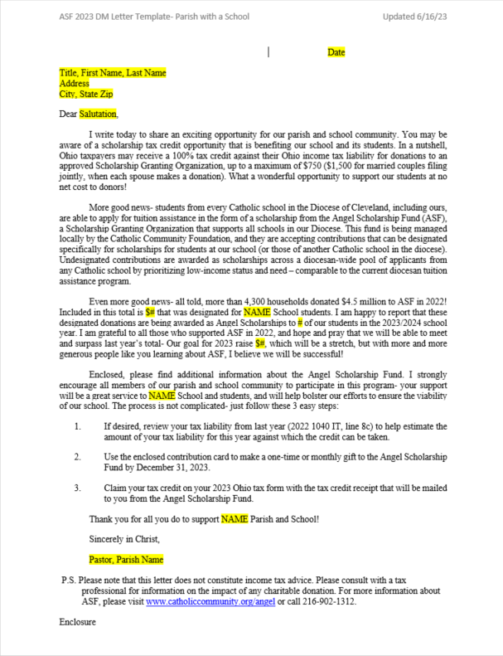
- ASF flyer- 2-sided
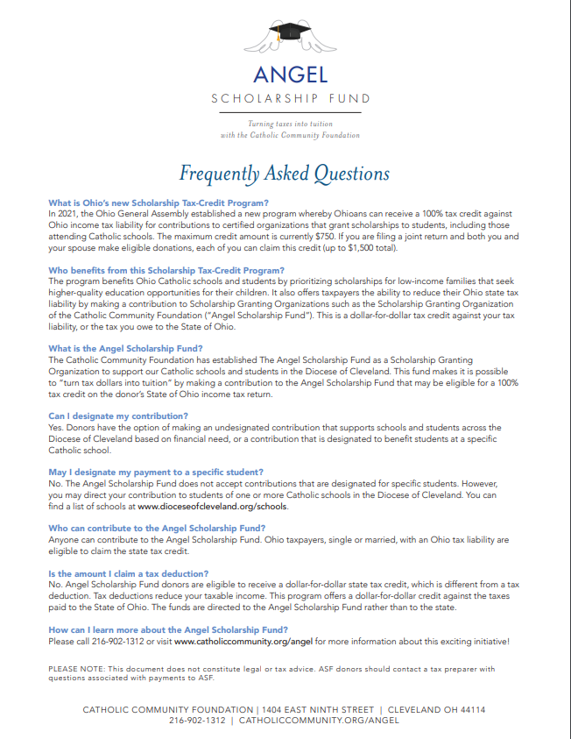
- ASF contribution form
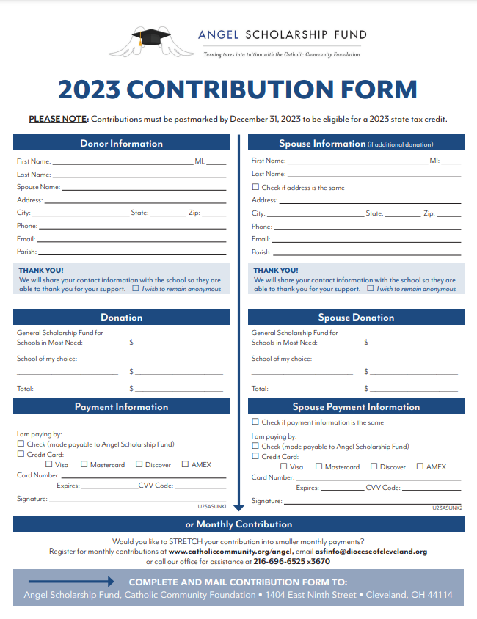
- ASF #9 Return Envelope
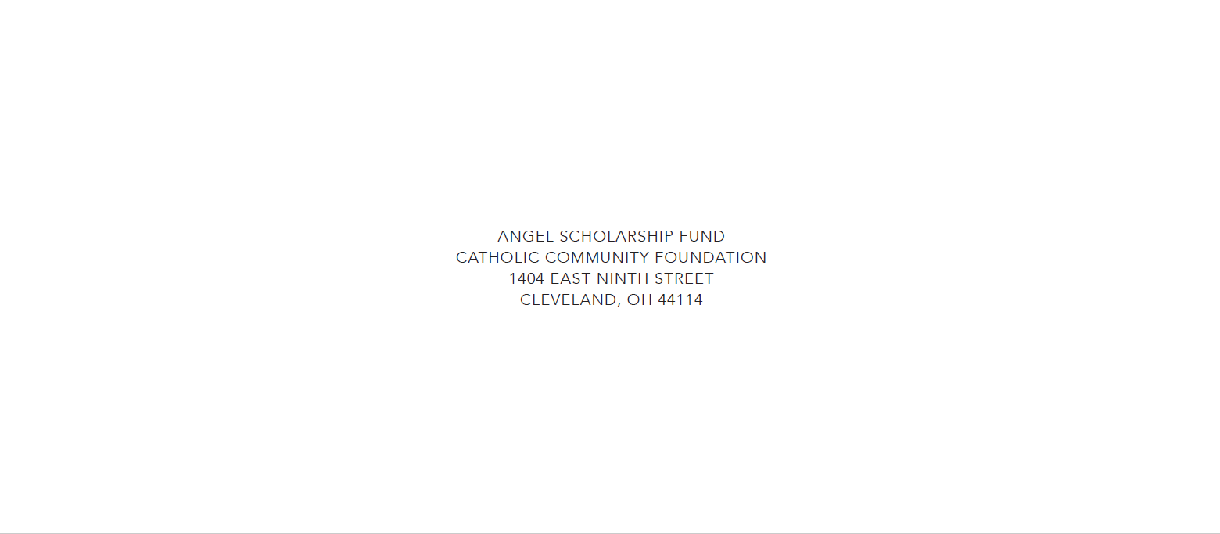

INSTRUCTIONS
Please carefully read the following steps for creating, preparing, and sending your ASF Mailers.

STEP 1- Alert the ASF office as to your intention to send an ASF direct mailing to your constituents. Information to provide:
- Organization Name
- Name of Person preparing the mailing
- Contact information
- # of letters you plan to send
- Date of the mailing
Send to Fred Roberts: froberts@catholiccommunity.org / 216-902-1312

STEP 2- Personalize and print a cover letter
- The most important aspect of the letter is its personalization. “Dear Parishioner” letters are strongly discouraged!
- A personalized letter requires clean data to complete a mail merge that produces professional looking letters.
- The number of letters that are printed will correspond with the number of flyers, contribution cards, return envelopes, and #10 business envelopes.
- A handwritten signature from the pastor/president/principal is encouraged.
- The cover letter should be printed on your parish/school letterhead.
- Print letters in ALPHABETICAL ORDER.

STEP 3- Print and fold the ASF flyer
- This is a two-sided flyer that can be printed on a color printer/copier.
- The flyer should be folded twice to fit in a #10 business envelope.

STEP 4- Print the ASF Contribution Form
- This file is formatted for an 8½ x 11 sheet.
- This form should be folded twice; once filled out it is mailed back in a #9 return envelope.
- It is acceptable, but not necessary, to customize the form with the school name.

STEP 5- Print #9 Return Envelope
- Contributions will be sent directly to ASF.

STEP 6- Print and Affix Mail Labels
- Labels should be printed IN ALPHABETICAL ORDER.
- Affix labels to #10 envelopes
- #10 envelopes should have parish/school return address.

STEP 7- Prepare Mailers
- Cover letter goes on top, then flyer, then contribution card and return envelope.
- Insert into labeled #10 business envelope
- PRIOR TO SEALING- DOUBLE CHECK EACH MAILER, ENSURE NAMES ON LABEL AND COVER LETTER MATCH!
- Seal letters
- Apply first class postage to each envelope

STEP 8- Drop Mailing
- Take mailers to the post office.

STEP 9- Contact the ASF office
- Confirm mail date and number of mailers.

CONGRATULATIONS! FOLLOWING THESE STEPS WILL PUT YOU ON THE PATH TO GENERATING ANGEL SCHOLARSHIP DOLLARS.

