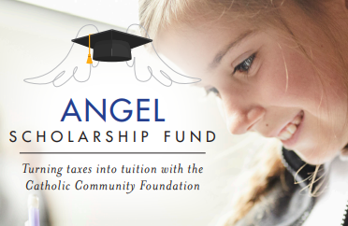

2023 Bulletin/Newsletter Blurb #2

Angel Scholarship Fund- Back in 2023!

The Angel Scholarship Fund (ASF) is a State of Ohio approved Scholarship Granting Organization. Donors to ASF may be eligible for a 100% tax credit on their State of Ohio income tax return for the year the contribution is made. ASF donations are awarded as tuition assistance for K-12 students in the Diocese of Cleveland, and donors may designate a school/schools to receive their donation.

Here’s how it works*:

The maximum credit amount is $750 per individual; married couples that file a joint return can each claim this credit if both spouses make eligible donations ($1,500 total). Please note this is a non-refundable credit, which means that the amount of the credit cannot exceed the amount owed in state taxes. Just follow these three steps:

STEP 1- Estimate your 2023 Ohio state tax liability
STEP 2- Make your donation to ASF
STEP 3- Claim your scholarship tax credit when you file your 2023 State of Ohio taxes

* This does not constitute income tax advice. Always consult with a tax professional for information on the impact of any charitable donation.

Contributions can now be made that are eligible for the credit in the 2023 tax year. Please visit www.catholiccommunity.org/angel to make an online contribution or download a mail-in form.

For more information, call, email or scan:
    - / asfinfo@dioceseofcleveland.org /

