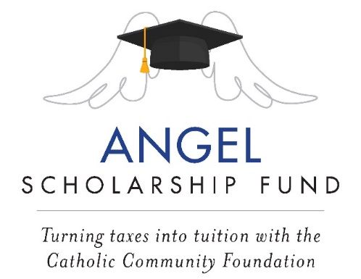

March 2023 Pulpit Announcement

- Schools/Parishes with a parish school

Angel Scholarship Fund- Important Tax Information

Many thanks to all who donated to the Angel Scholarship Fund in 2022. NAME school received ## contributions totaling $$, which will provide tuition assistance for our students in the 2023/2024 school year. Please see today’s bulletin for important information on filing 2022 state taxes.

- Parishes supporting multiple schools

Angel Scholarship Fund- Important Tax Information

Many thanks to all who donated to the Angel Scholarship Fund in 2022. ## of our parishioners contributed $$, which will provide tuition assistance for Catholic school students in the Diocese of Cleveland for the 2023/2024 school year. Please see today’s bulletin for important information on filing 2022 state taxes.

