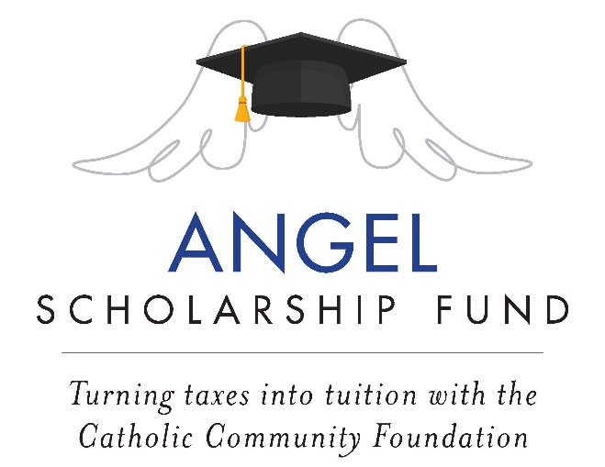

2022 Year-end Bulletin/ Newsletter/ Pulpit Announcement:

ACT NOW to claim your 2022 state tax credit!

Calling all State of Ohio taxpayers! A new Scholarship Tax Credit program makes it possible to make a no-net-cost gift that will turn your tax dollars into tuition for students of <Insert School Name> or another school in the Diocese of Cleveland.

How does it work? It’s simple- make a contribution to the Angel Scholarship Fund (ASF) by December 31st that will be eligible for a 100% tax credit of up to $750 ($1,500 if married filing jointly) against your 2022 state tax liability. ASF will send you a tax receipt for filing your 2022 state income taxes.

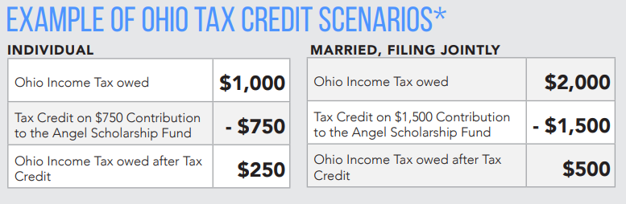

Three Steps to Reduce Your State Tax Liability AND Support Catholic Education*:
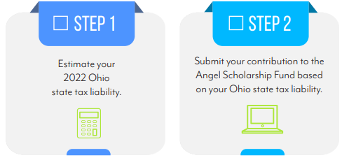

More information is available at www.catholiccommunity.org/angel / 216-902-1312

