May Follow-Up In Pew Appeal for the Hungry and Homeless
Announcement Weekend, May 13-14, 2017

Bulletin and Pulpit Announcements:

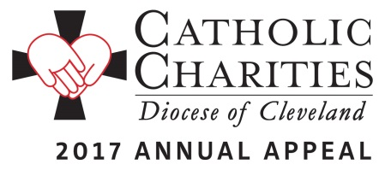
Next weekend, we will be participating in a follow up In-Pew Appeal for Catholic Charities, which will benefit the Hungry and Homeless throughout our Diocese. * The money raised from this Appeal will provide for fundamental needs, such as food, hot meals, shower facilities, and clothing, as well as training and case management programs that provide for new beginnings.

All new, increased and additional gifts made in the in-pew envelopes available next weekend or donated online at www.CatholicCommunity.org/challenge will be matched dollar for dollar up to $100,000 and all proceeds from this weekend will be invested in the Hungry and Homeless, by providing for the basic needs and new beginnings for those in our Diocese who are most vulnerable.

Please give as generously as possible. From Matthew’s Gospel: Amen, I say to you, whatever you did for the least among us, you did it for me.”

*Insert Optional Local Initiative
St. Elizabeth Center, Lorain:
For this collection, parishioners will also have the opportunity to donate directly to St. Elizabeth Center in Lorain. When it opens this fall, the center will combine services of the St. Joseph Shelter and the 8th Street Family Center, to provide overnight shelter with meals, shower facilities, laundry, food pantry and emergency assistance.

Blessed Trinity Food Pantry, Akron:
For this collection, parishioners will also have the opportunity to support a critical need in downtown Akron: Blessed Trinity Food Pantry. This pantry provides monthly food supplements and weekly hot meals to families in need.

Lake and Geauga County Food Pantry:
For this collection, parishioners will also have the opportunity to support food pantries throughout Lake and Geauga County that need it the most, including local parish food pantries and Food Force programs.

Bishop Cosgrove Center, Cleveland:
For this collection, parishioners will also have the opportunity to donate directly to Bishop Cosgrove Center in downtown Cleveland. The Center serves as one of the largest day drop in Centers in Greater Cleveland, providing hot meals, showers, a choice food pantry, and clothing closet. Specialized programs for veterans, employment and training will continue to provide resources for new beginnings.

May Follow-Up In Pew Appeal for the Hungry and Homeless
Commitment Weekend, May 20-21, 2017

Bulletin and Pulpit Announcements:
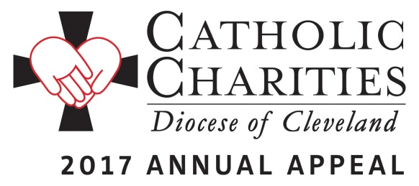
This weekend, we will participate in a follow up to the in-pew commitment for Catholic Charities which had taken place in February. This is not a special collection; rather, the Catholic Charities Annual Appeal represents the chance for all Catholics to make a significant pledge, payable in installments, to Catholic Charities, Diocese of Cleveland in order to support its mission of a society that stands united in its support of the “least among us.” All of the money raised from this weekend’s Appeal will provide help for the Hungry and Homeless, through fundamental needs, such as food, hot meals, shower facilities, and clothing, as well as future needs through training and case management programs.

All new, increased and additional gifts made in the in-pew envelopes available this weekend or donated online at www.CatholicCommunity.org/challenge will be matched dollar for dollar up to $100,000. Donations this weekend may also be designated to any of three regional sites that are most in need of support. Please consider a generous gift that will transform the lives of the 400,000 who are served each year in Northeast Ohio. Please pray for the success of the appeal, which provides for essential programs and services in need throughout all eight counties of the Diocese of Cleveland.

On behalf of the poor and needy of Northeast Ohio, thank you! We invite you to view the stories of inspiration and more information at www.catholiccommunity.org/2017Appeal.

