The following bulletin is recommended for reporting your parish’s progress towards goal. Please edit them, using the Parish Stats to fill in the sections highlighted in yellow to make the announcement specific to your parish.

Bulletin and Pulpit Announcements
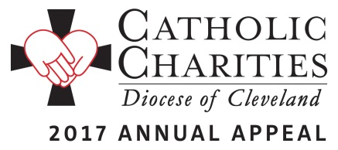
Thank you! Catholic Charities is able to provide hope through the support of the faithful throughout our diocese. As of May 31, 43,287 donors have pledged $10,731,532 toward our $12M goal and 78 parishes have exceeded their own goals!

You Did it for Me. <Insert number of donors> parishioners of <insert parish name> have pledged $<insert dollars pledged> toward our parish goal of $<insert parish goal>. That is <insert % to goal> of our overall goal! From Matthew’s gospel, Jesus tells us “Amen, I say to you, whatever you did for the least among us, you did it for me.” Your support of the 2017 Catholic Charities Annual Appeal provides help to the least among us, in the name of Jesus. If you have not yet donated, please consider a generous gift to the Catholic Charities Annual Appeal. Contact Holly Hebebrand at 800-869-6525 ext. 1049 to make a gift by phone or make a secure gift at http://www.catholiccommunity.org/donate.

We invite you to view the stories of inspiration and see the faces that you have impacted through your generosity. Please visit: http://www.catholiccommunity.org/2017appeal.

