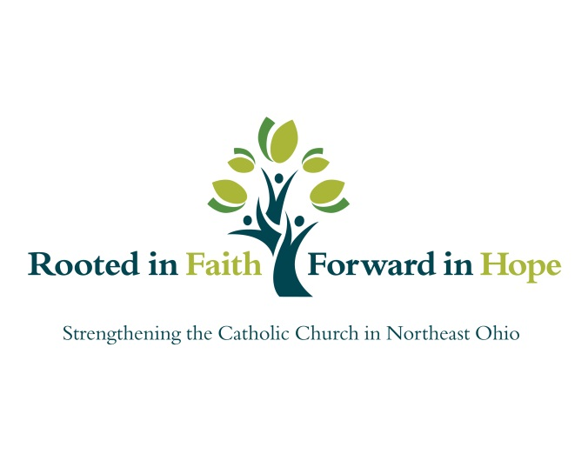
Strengthening Our Faith Grants
December 2016
School | City | Intended Use
La Sagrada Familia Parish | Cleveland | Support the education of the PSR and RCIA participants and their parents in the sacramental programs.
Mary Queen of Peace Parish | Cleveland | Buy supplies/materials needed for Reconciliation and Reconciliation Retreat.
St. Albert the Great Parish | North Royalton | Create and launch sacramental religious education programs.
St. Ambrose Parish | Brunswick | Facilitate parents in identifying their innate God-given strengths as they continue their role as primary educators of their children's faith.
St. Bartholomew Parish | Middleburg Heights | Assist in continuing to enhance our very limited sacramental resources regarding sacramental teaching to a more inviting, modern curriculum.
St. Colette Parish | Brunswick | Sacramental preparation equipment, materials, stipends and retreat costs.
St. Francis Xavier Parish | Medina | Retreat that will offer faith enriching opportunities for our students; it will also offer catechesis and reconciliation that will strengthen them both intellectually and spiritually.
St. James Parish | Lakewood | A class set of YouCat and study guides will allow for implementation of the General Guidelines for Confirmation preparation.
St. John Bosco Parish | Parma Heights | FORMED is an inter-net on line access to the best Catholic content in place. Access to FORMED will continue to foster greater adult faith formation and sacramental formation within the parish.
St. Malachi Parish | Cleveland | "Catechesis is a moment in evangelization." This program will evangelize our Catholic families through catechizing Confirmation candidates and their families.
Our Lady of Victory Parish | Tallmadge | Continue to work toward the education and faith formation of our parishioners, in particular our catechists and parishioners in general and to enable us to continue to expand and more fully attempt to re-engage the parishioners who are on the fringes of parish life, in particular only during times of sacramental preparation.
St. Mary Parish | Hudson | Enabling each child preparing for First Reconciliation and First Communion to have their own Bible in the home will advance our mission to evangelize both children and parents as they prepare to receive the Sacraments.
Ss. Robert and William Parish | Euclid | Family sacramental preparation workbooks are provided for the families and are to be completed as a parent/child project at home.
Communion of Saints Parish | Cleveland Heights | The development of a Youth Ministry website with widgets and relevant information for teens and their parents; a robust social media presence putting interested youths in touch with the Parish by means of virtual connection; the purchase of hard technologies that will allow already-engaged teens to share the message of the Church and Youth Ministry with the wider community; the continued outreach to parish and community teens.
Mary Queen of Peace Parish | Cleveland | Conquest (boys)/Challenge (girls) is a program to help youth grow in knowledge of their faith, friendship with Christ and to make a difference and have a positive impact on their families and friends.
Our Lady Queen of Peace Parish | Grafton | Forming a Young Adult Ministry to provide a means for faith formation and a support network for the young adults of the parish.
Saint Ambrose Catholic Parish | Brunswick | Come Back Home will address the problem that St. Ambrose and other churches are facing: that of young adults leaving the Church in their young adulthood. Under the leadership of the Spiritual Life Coordinator and through the creation of an intern position, the development of a core team of adults, young and old and the building of a coalition, St. Ambrose will address the issue and create concrete steps and tools to improve our outreach and create best practices of re-engagement.
St. Boniface Parish | Cleveland Heights | This program will help the Vietnamese kids, and young adults will learn both faith and wellness language and traditional culture. It will strengthen, promote growth and enrich the worship life of the kids and young adults.
St. Francis de Sales Parish | Akron | Our program proposes to partner with parents to help them grow in knowledge and confidence to be these primary educators and thus the mission of both the Church and parish is advanced.
St. Francis Xavier Parish | Medina | Middle school children will participate in service projects outside of Medina to help them see a global picture of the amount of need that is out there.
St. Luke the Evangelist Parish | Lakewood | Purchase materials and train volunteers to better engage young people.
St. Mary Parish | Hudson | Fund more of our Core team members to attend the National Catholic Youth Ministry Convention.
St. Noel Parish | Willoughby Hills | St. Noel and Divine Word are hosting a week-long Middle School Camp.
St. Patrick Parish | Wellington | Funding to provide our parish with Wi-Fi in the Church hall, a wide screen television and an LCD projector.
SS. Robert and William Parish | Euclid | The grant would allow us the necessary means to provide more adequate training and implementation tactics for our catechists: funds for 7 people to attend the Catholic Youth Ministry Conference in Arizona.
Immaculate Conception Parish | Willoughby | Obtaining the Faith and Life Series Parish Catechist Manuals and Family Guide and upgrades to the current outdated video technology, catechists.
Immaculate Heart of Mary Parish | Cuyahoga Falls | Subscription to FORMED which provides access to Catholic programs, movies, audio files and books. And, purchase a Theology of the Body (TOB ) program for the ongoing use by the 8th grade school and PSR students and their parents.
Our Lady Help of Christians Parish | Litchfield | OHLC is requesting a grant to advance our mission of educating our children, families and catechists with the use of electronic media. Also, we are making a mission trip to Cincinnati with the Catholic Heart Work Camp and will need assistance with funding.
St. Francis Xavier Parish | Medina | Utilize available media materials to educate children, youth, young adults and parents.
St. Francis Xavier Parish | Medina | Bring the message of the Gospel into the 21st century through means of podcasting.
St. John Bosco Parish | Parma Heights | Adult Education Program: to address a growing diverse population with engaging spiritual development, guest speakers and community outreach.
Communion of Saints Parish | Cleveland Heights | Funds for Vacation Bible School.
Our Lady of Peace Parish | Cleveland | Purchase materials to instruct our PSR students to better understand the Sacraments, and to provide most needed resources to offer meaningful retreats for the sacraments.
St. Francis Xavier Parish | Medina | Vacation Bible School.
St. Joseph Parish | Cuyahoga Falls | Technology advancement to allow for greater opportunities for the catechists to apply web-based services and applications for enhanced catechetical instruction.

