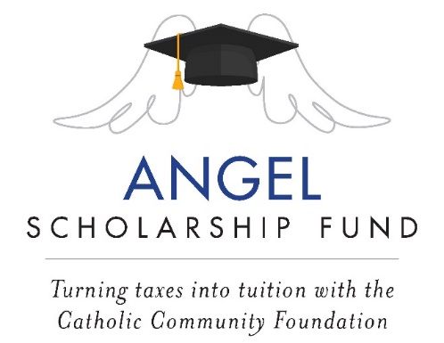

2023 Year-end Message #1
For: Bulletin/ Newsletter/ Pulpit Announcement/E-blast

BE AN ANGEL!

Did you know the State of Ohio scholarship tax credit program makes a “no-net cost” donation possible that greatly benefits (SCHOOL NAME School students / Catholic school students throughout the Diocese of Cleveland)?

It’s a Win-Win for:

- Donors to the Angel Scholarship Fund that may be eligible for a 1:1 state tax credit against their Ohio tax liability (up to $750 for individuals or $1,500 for married couples filing jointly, when both spouses contribute $750); and
- Catholic school students K-12 that receive scholarships.

Here are two examples of how the program works*:

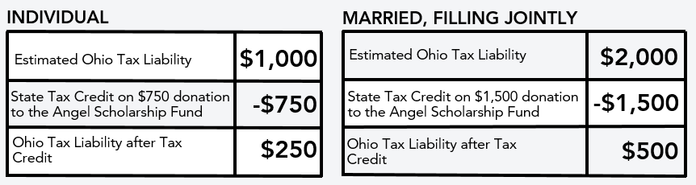

Two notes on the state tax credit:

- The credit is applied against your Ohio tax liability. For clarification, your Ohio tax liability is the amount of taxes that you owe to the State of Ohio for the tax year (it is not the amount that you may have you pay when you file your tax return if sufficient amounts were not withheld during the year). Therefore, even if you already anticipate receiving a refund due to overpayments during the year, your donation could increase the amount of your refund to the extent of your actual tax liability.

- It is a non-refundable credit, which means the amount of the state tax credit cannot exceed the amount of the Ohio tax liability.

Contact the ASF office for more information on how to “Be an Angel!”
216-902-1312 / asfinfo@catholiccommunity.org

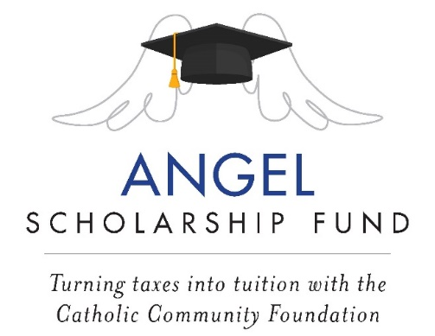

2023 Year-end Message #2
For: Bulletin/ Newsletter/ Pulpit Announcement/E-blast

THANK YOU 2022 ANGELS!

Many thanks to all who have supported the Angel Scholarship Fund (ASF). Your generosity made it possible for us to raise more than $##### for SCHOOL NAME students in 2022, and to award ## Angel Scholarships in 2023/2024!

Our hope and prayer is that more of our families will participate in this wonderful scholarship tax credit program by making a “no-net cost” donation for the 2023 tax year, and that we will be able to secure $GOAL for our Angel scholars in 2024/2025.

There are multiple ways to donate:
Contact the ASF office for more information on how to “Be an Angel!”
216-902-1312 / asfinfo@catholiccommunity.org

Notes for Parishes:

- If your parish is not linked to one specific school, then the first paragraph should read:
We thank all those who have supported the Angel Scholarship Fund (ASF). Your generosity made it possible for PARISH NAME to raise more than $##### for Catholic school students throughout the Diocese of Cleveland) in 2022.

- If your parish is linked with one specific school, then list the number of Angel Scholarships that you awarded in 2023.

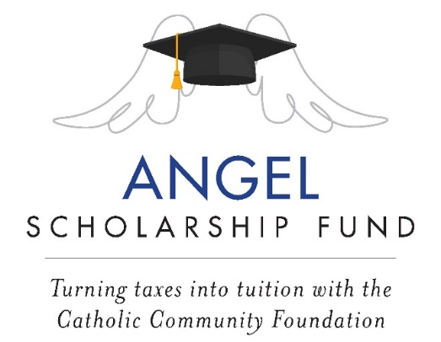

2023 Year-end Message #3
For: Bulletin/ Newsletter/ Pulpit Announcement/E-blast

Be an Angel in 2023!

Donations to the Angel Scholarship Fund (ASF) helped make it possible for our parishes and schools to raise more than $4.5 million in 2022, and for a growing number of families to receive tuition assistance for their children to attend a high quality Catholic school.

As we approach the end of the 2023 calendar year, our hope and prayer is for the number of ASF supporters to grow so that we may achieve even greater success. We encourage all Ohio taxpayers to consider making an ASF donation by December 31, 2023* that may be eligible for the state tax credit when filing a 2023 Ohio tax return.

IT’S A WIN-WIN- Eligible donors receive a dollar-for-dollar tax credit**, and students get scholarships! There are multiple ways to donate:

Contact the ASF office for more information on how to “Be an Angel!”
216-902-1312 / asfinfo@catholiccommunity.org / www.catholiccommunity.org/angel

* While the state has extended the donation deadline (to April 15, 2024) to claim the tax credit for 2023, if you are able to respond by December 31st, then your donation will be available to award to students in 2024.

**Up to $750 for an individual or $1,500 if married filing jointly.
This does not constitute legal or tax advice – please contact your tax professional.

