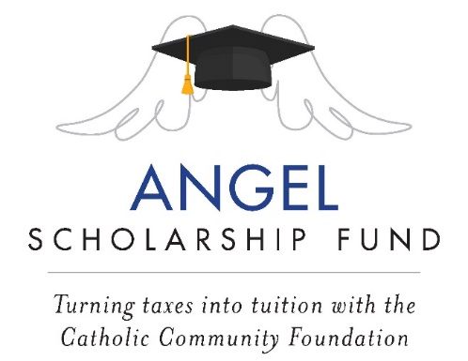

March 2023 Bulletin/ Newsletter Item:

- Schools/Parishes with a parish school

Angel Scholarship Fund- Important Tax Information

The Angel Scholarship Fund (ASF) is a State of Ohio approved Scholarship Granting Organization. Donors to ASF may be eligible for a 100% tax credit on their State of Ohio income tax return for the year the contribution is made. The maximum credit amount is $750 per individual; married couples that file a joint return can each claim this credit if both spouses make eligible donations ($1,500 total).

2022 was a smashing success! Many thanks to all who designated their ASF contribution to NAME School in 2022! We received a total of ## contributions totaling $$, which will provide tuition assistance for our students in the 2023/2024 school year.

2022 ASF Donors- Please Note:
- ASF Tax Receipts have been sent to ASF donors for preparing their taxes.
- Donations to ASF are nonrefundable credits; and the total of your nonrefundable credits cannot exceed the amount of your state tax liability. Ohio nonrefundable credits are entered on line 9 of the Ohio IT 1040.*:
* This does not constitute legal or tax advice. ASF donors should contact a tax preparer with questions associated with payments to ASF.

Back again in 2023:
ASF contributions can now be made for the 2023 tax year at www.catholiccommunity.org/angel.

For more information, call, email or scan:
216-902-1312 / asfinfo@dioceseofcleveland.org /

- Parishes supporting multiple schools

Angel Scholarship Fund- Important Tax Information

The Angel Scholarship Fund (ASF) is a State of Ohio approved Scholarship Granting Organization. Donors to ASF may be eligible for a 100% tax credit on their State of Ohio income tax return for the year the contribution is made. The maximum credit amount is $750 per individual; married couples that file a joint return can each claim this credit if both spouses make eligible donations ($1,500 total).

2022 was a smashing success! Many thanks to all who donated to the Angel Scholarship Fund in 2022. ## of our parishioners contributed $$, which will provide tuition assistance for Catholic school students in the Diocese of Cleveland for the 2023/2024 school year.

2022 ASF Donors- Please Note:
- ASF Tax Receipts have been sent to ASF donors for preparing their taxes.
- Donations to ASF are nonrefundable credits; and the total of your nonrefundable credits cannot exceed the amount of your state tax liability. Ohio nonrefundable credits are entered on line 9 of the Ohio IT 1040.*:
* This does not constitute legal or tax advice. ASF donors should contact a tax preparer with questions associated with payments to ASF.

Back again in 2023:
ASF contributions can now be made for the 2023 tax year at www.catholiccommunity.org/angel.

For more information, call, email or scan:
216-902-1312 / asfinfo@dioceseofcleveland.org /

