Estimating Tax Liability

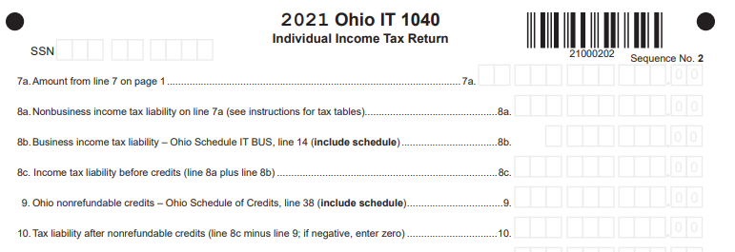

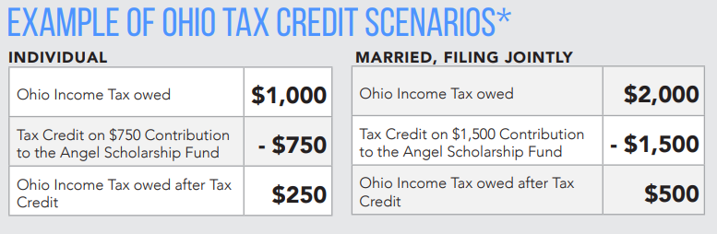
10
8c
9

Notes:

- Line 8c- Income tax liability before credits-
  - This is the amount of Ohio Income Tax owed

- Line 9- Ohio nonrefundable credits
  - Includes amount donated to ASF
  - Maximum amount is $750 for individuals or $1,500 for married couples filing jointly, where each spouse gives $750
  - This amount cannot be greater than line 8c
  - This amount is subtracted from the amount on line 8c

- Line 10- Tax liability after nonrefundable credits
  - Ohio Income Tax owed after subtracting nonrefundable credits
  - Cannot be less than $0 (e.g., if line 8c is $500, the maximum amount for line 9 is $500)

