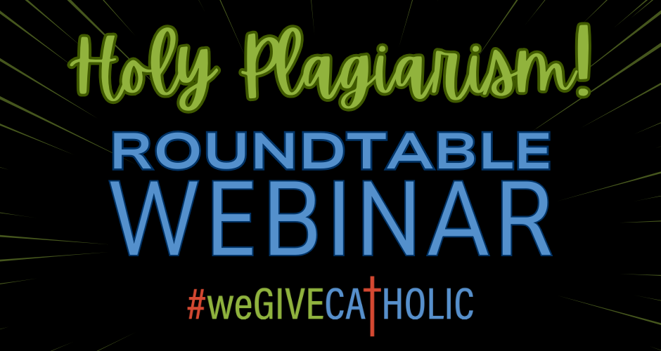

Tuesday, April 23, 2024

1. Holy Trinity School (Avon)

Initial 2023 Goal: $10,000

Actual 2023 Total: $20,630

2022 Total Raised: $5,405

FEATURED STRATEGY:

- Utilizing Mightycause’s Text-to-Give Feature to raise $7,755 from 68 donors
  - Text-to-give provides you another avenue and opportunity for donors to donate to your cause. Find out how easy implementing a text-to-give campaign HERE.
  - Donors have the ability to donate directly from a smart device.
  - Holy Family parents were already accustomed to receiving texts from school – use the FACTS text alert system
  - Sent texts to parents:
    - During Early Giving period
    - The day before (Mon., Nov. 27)
    - Day of – Every three hours announcing contests
  - People already use/trust their phones to pay bills, why not utilize the convenience for fundraising?

OTHER EXCELLENT CAMPAIGN COMPONENTS:

- Used prizes to incentivize participation, generate buzz, and steward donors
  - Most prizes were donated or free to the school
  - Had multiple levels so the larger the donation, the more prizes you were eligible for
  - To motivate donations during Early Giving period, daily ‘lunchroom’ student prizes were offered (Special treats delivered to students during lunch period including Crumbl Cookies, Mitchell’s Ice Cream, Chick-Fil-A, etc.)
  - Some examples of their prize structure include:
    - $250 OR MORE - LUNCH WITH AVON POLICE OFFICER NICK AND A RIDE IN HIS POLICE CAR WITH A FRIEND
    - $500 OR MORE - NIGHT OF HIDE AND SEEK AT SCHOOL W/ 3 FRIENDS
    - $750 OR MORE - SMASH A PIE IN THE PRINCIPAL'S FACE
    - LARGEST DONATION - SLIME MR. MO ON LAST DAY BEFORE BREAK
  - Some examples of their day-of contests:
    - 8 TO 11AM - GET OUT OF CLASS TO PLAY PSS IN GYM W/ A FRIEND
    - 11AM TO 2PM - PANERA TRIP FOR LUNCH WITH MRS. KUCHTA
    - 2 TO 5PM - SILLY STRING WAR WITH 5 FRIENDS AT RECESS
    - 5 TO 8PM - WRAP MR. MO UP IN CHRISTMAS WRAP DURING LUNCH WITH A FRIEND
    - 8PM TO 12PM - MOVIE & POPCORN NIGHT W 3 FRIENDS ON BIG SCREEN IN GYM
  - Made a prize flyer that was included in principal’s post, email, website, and social media
  - Made sure prizes were focused on experiences for the students
  - Getting principal on board was key!
  - Each experience is content for social media! (Remember to take photos and tag #weGIVECATHOLIC to steward donors)

2. Our Lady of Lourdes Shrine (Euclid)

Initial 2023 Goal: $72,000

Actual 2023 Total: $95,475

2022 Total Raised: $66,735

FEATURED STRATEGY:

- Hosting a Giving Celebration on Giving Tuesday
  - Met with Fred and Jackie in person to discuss strategies since this was her first year running the campaign
    - CCF team became her cheerleader every step of the way (Yes, we meet with orgs. in person to discuss how to make the campaign a success!)
  - Hosted an event at Our Lady of Lourdes Shrine to coincide with cookie fundraiser
    - Many people came and gave checks or checks while ordering their cookies
    - Also had QR code available to give online
  - Emailed their regular email list, but also emailed donors from 2022 with invitation to the event
  - Used flyers, emails, and word of mouth to promote
  - Encouraged dropping off offline gifts of cash or check to avoid fees
  - Chose worthy projects: project needs were very visible to visitors -repair the steps and surrounding area in front of the candle house
    - Those attending the event could CLEARLY see with their own eyes the need for the funds
  - Bishop did attend event, which helped build excitement for the day

OTHER EXCELLENT CAMPAIGN COMPONENTS:

- Storytelling at its BEST! Santa promised the Blessed Mother he would help fix the stairs. Click HERE to read all about it.
- #WeGIVECATHOLIC was very close to Sister Donald's heart. After she passed away in 2023, the sisters asked people to help us fulfill her dreams
- Profile page was full of very inspiring videos/testimonials and photos
  - Utilized Mightycause’s Media Gallery feature to showcase many touching videos and testimonies

3. Gilmour Academy (Gates Mills)

Initial 2023 Goal: $100,000

Actual 2023 Total: $107,206

2022 Total Raised: $147,251

FEATURED STRATEGY:

- Engaging Alumni, Past Parents, and Staff Members to get Involved on Giving Tuesday
  - Unlike like most orgs, Gilmour Academy raises money for their annual fund, not for a tangible project
  - Tapping into past parents and alumni has been incredibly successful for GA
  - Matching donors must be found amongst these giving groups.
    - Larger gifts are split up into smaller matches throughout the day
  - E-newsletter go out bi-monthly to all donors showing the impact of philanthropy including faculty blurbs, videos, quotes from students, storytelling, etc.
  - Mailed a save-the-date postcard to anyone who donated in the past 5 years with call-to-action (QR code). Goal was to have these land in mailboxes at beginning of Early Giving period.
  - Targeted each group with creating four challenges to spark excitement (instead of P2Ps)
    - Past Parents Giving Challenge – Goal, $5,000; Raised, $11,350
    - Gilmour Academy & Glen Oak School Alumni Challenge – Goal, $7,500; Raised, $9,725
      - Personal phone calls are made every year prior to Giving Tuesday. These take the most time, but have the largest impact. Calls were made to anyone who has supported in the past or who has not yet given in current year. If no one answers (Nicole and team leaves A LOT of voicemails), they put a call-to-action in the VM.
    - GA Faculty & Staff Challenge! – Goal, 50 donors; Achieved, 56 Donors
      - Be sure to thank staff throughout the year
      - Giving back to the school is an expectations when hired
      - Staff receives dress down days
      - Participation is more important than dollar amount
    - Gilmour Parent Fundraising Challenge – Goal, 100 Donors; Achieved 56 Donors
      - Current parents are hard to tap into – use yard signs, stickers, and newsletters

OTHER EXCELLENT CAMPAIGN COMPONENTS:

- Spent the week after Giving Tuesday calling every single donor (195!) by phone.
- Use every opportunity to share the good news of the day – GA created a social media post to announce which donor allowed them to reach their goal.
- Be sure to track retention rate year after year. (Learn how to use this Mightycause tool HERE.)
- Everything GA does is inexpensive (yard sign are most expensive, but under $200)
- Utilize the free graphic design tool, Canva.
  - Using the #weGIVECATHOLIC toolkit, download the #wgc logo and add a personal branding aspect to make it your own.

4. St. Helen LifeTeen (Newbury)

Initial 2023 Goal: $25,000

Actual 2023 Total: $27,178

2022 Total Raised: $56,585

FEATURED STRATEGY:

- Transitioning #weGIVECATHOLIC to being the one and only fundraiser of the year
  - Previously hosted annual “Night at the Opera” events, but has now switched to one annual fundraiser (#weGIVECATHOLIC)
  - #weGIVECATHOLIC is much more profitable, with greater overhead and less labor intensive
  - Education for parents and donors
  - Has had great success by reaching out to previous “table buyers” to ask them to transition to become a #weGIVECATHOLIC donor instead
  - Unique because they do not have one specific tangible goal, the funds raised bridges the gap (created great graphic to help get the message out)
  - Created great graphic explaining how #weGIVECATHOLIC helps offset the faith-filled experience for teens.
  - Father Jay is incredibly invested in Life Teen and sees incredible value in it
  - 2023 proved: They could surpass their goal while still having a successful #wgc school campaign (raised $15,625) AND raised the most for the Angel Scholarship Fund in the diocese!

OTHER EXCELLENT CAMPAIGN COMPONENTS:

- Social media (IG and FB) was a huge help for their campaign. St. Helen Life Teen asked their CORE members to share their posts which reached people in the CORE members networks that use to go to Life Teen at St. Helen’s
- Throughout the year, donors are updated via email on the projects, trips, and good works Life Teen is doing
- 2023 success is due to: starting the planning process earlier, watching all of the webinars for tips and tricks, spreading the word year round to parents and donors.
- Check out their amazing TikTok video! C:\Users\jbrauser\Downloads\export_1712872882586.MOV
- Goals for 2024: Get the parish more involved

5. Cleveland Central Catholic High School (Cleveland)

Initial 2023 Goal: $35,000

Actual 2023 Total: $50,868

2022 Total Raised: $723

FEATURED STRATEGY:

- Developing a Strategic Plan for using Personal Solicitation to have a more Impactful Connection with Donors
  - Bigger dollars come from 1-on-1 meetings
    - No general asks; asked specifically for #weGIVECATHOLIC
  - Engaged board members EARLY!
    - The board knew of the campaign ahead of time
    - Wanted them to make commitment in the 1st half of the school year
    - Reminded members their #wgc gift would count towards the Iron Man Society (membership is a min. $2,500 gift/year)
    - Because commitment was made so early in the school year, many still gave to their spring auction
    - Tim sent text messages to those donors he personally knew reminding them it was Giving Tuesday and these were SUPER impactful
    - Many board members gave verbal commitments/pledges
      - This is 100% acceptable (and encouraged!) for #weGIVECATHOLIC
      - Money was not actually received until a later date but was entered as offline gift
      - It is very important that these gifts still be entered as offline gifts
  - Now that you have the money from asking before the giving day, how can you use to the greatest advantage?
    - Use large gifts to gauge what you set your goal at
      - If you know you have $15K ahead of time, you most probably can set a goal above $30K
    - Break up large matches in smaller ones to create more wins (smaller = more attainable goals!)
    - Perception is reality - people only know what they see
      - Advertise your matches ahead of time, but keep some in your back pocket to create buzz on the giving day. This builds giving day excitement!

OTHER EXCELLENT CAMPAIGN COMPONENTS:

- CCCHS outsourced a marketing consultant to help with branding, graphics, and updated website design
- Get inspired by CCCHS’s #weGIVECATHOLIC website! It uses brand colors, logos, videos, LOTS of smiling faces, and fantastic graphics.
- Exception 30-second campaign contest video explaining a day in the life of a CCCHS students created energy and buzz
  - People really got engaged with the contest and put CCCHS on the map for a successful giving day.
  - Check it out: https://vimeo.com/884233100
  - Important for donors to see ahead of giving day
  - Added video to newsletters, Facebook, and Instagram
  - Emailed to 6K+ constituents (alumni, donors, parents, and students)

