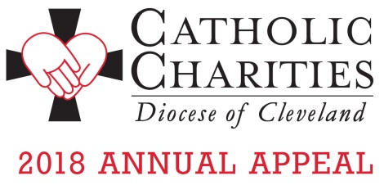

To place the 2018 Annual Appeal Video on your website:

Copy and paste the full link below for each of the videos you want to share on your website, in your social media and your parish emails and newsletters.

Full Appeal Video

<iframe width="560" height="315" src="https://www.youtube.com/embed/1FfeYVWzoVw" frameborder="0" allow="autoplay; encrypted-media" allowfullscreen></iframe>

Shortened video segments

Camp Christopher
<iframe width="560" height="315" src="https://www.youtube.com/embed/eFT1QizayEo" frameborder="0" allow="autoplay; encrypted-media" allowfullscreen></iframe>

St. Martin de Porres Family Center
<iframe width="560" height="315" src="https://www.youtube.com/embed/MsDISickrvU" frameborder="0" allow="autoplay; encrypted-media" allowfullscreen></iframe>

St. Elizabeth Center
<iframe width="560" height="315" src="https://www.youtube.com/embed/RD8iKFUJx54" frameborder="0" allow="autoplay; encrypted-media" allowfullscreen></iframe>

For additional information, please contact Karen Joyce at kjoyce@catholiccommunity.org or by phone at 216-696-6525 ext. 1910.

For additional information about the 2018 Annual Appeal visit www.catholiccommunity.org/2018Appeal.

