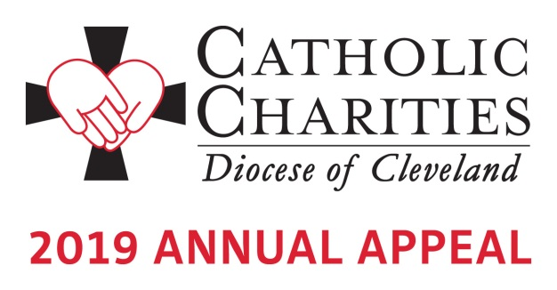

To place the 2019 Annual Appeal Video on your website:

Copy and paste the full link below for each of the videos you want to share on your website, in your social media and your parish emails and newsletters.

Full Appeal Video

<iframe width="560" height="315" src="https://www.youtube.com/embed/40o47UzpwXY" frameborder="0" allow="accelerometer; autoplay; encrypted-media; gyroscope; picture-in-picture" allowfullscreen></iframe>

Shortened video segments

St. Philip Neri Family Center
<iframe width="560" height="315" src="https://www.youtube.com/embed/QzLT9iIgYaQ" frameborder="0" allow="accelerometer; autoplay; encrypted-media; gyroscope; picture-in-picture" allowfullscreen></iframe>

St. Augustine Health Ministries
<iframe width="560" height="315" src="https://www.youtube.com/embed/rX7aogwmYGM" frameborder="0" allow="accelerometer; autoplay; encrypted-media; gyroscope; picture-in-picture" allowfullscreen></iframe>

Catholic Charities Disability Services
<iframe width="560" height="315" src="https://www.youtube.com/embed/SG7faGek2Tc" frameborder="0" allow="accelerometer; autoplay; encrypted-media; gyroscope; picture-in-picture" allowfullscreen></iframe>

For additional information, please contact Karen Joyce at kjoyce@catholiccommunity.org or by phone at 216-696-6525 ext. 1910.

For additional information about the 2019 Annual Appeal visit www.catholiccommunity.org/2019Appeal.

