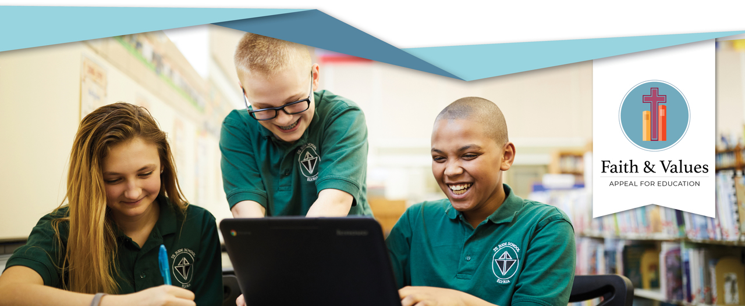**BULLETIN & PULPIT ANNOUNCEMENTS**

**Announcement Weekend – August 14-15, 2021**

Catholic schools make a profound impact on a child’s life. You can help provide more opportunities for students to obtain a Catholic education. Next weekend, a special parish appeal, the ***Faith and Values Appeal for Education***, will be held across the diocese to raise funds to help provide tuition assistance to needy students and their families right here in our diocese. Please be generous in your support of Catholic school students. Envelopes for this special appeal are included with your parish envelopes. You can make a secure donation online at www.CatholicCommunity.org/education or call 216-696-6525 x1530.

**Commitment Weekend – August 21-22, 2021**

Catholic Schools in the Diocese of Cleveland are changing the lives of children and their families. Thanks to the generosity of people like you who know the value of a Catholic education, last year more than 3,500 students received need-based tuition assistance. When you give to ***the Faith & Values Appeal*** to support tuition assistance for a Catholic school student, you are giving a gift that will live on in the lives of those served in our schools. Please pray that the generosity of our parishioners will continue to support the formation of our youth in Catholic schools where faith makes a difference. To donate online, go to www.CatholicCommunity.org/education or call 216-696-6525 x1530.