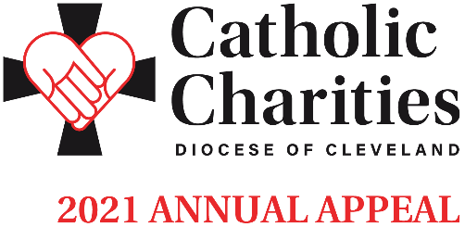

Leading Up To In-Pew Appeal | January 30-31 + February 6-7
Bulletin and Pulpit Announcements
Love Your Neighbor. Many parishioners received letters in January, inviting their support of the Annual Appeal. Please pray for the good work of Catholic Charities and make a pledge today. Your donation makes a difference!
Your support of the 2021 Catholic Charities Annual Appeal will help us serve those individuals who are most in need and most vulnerable. From Matthew’s Gospel: Whatever you did for the least of these, you did it for me. When we feed the hungry, take care of the sick, and welcome the stranger, we are also serving Jesus himself.
We appreciate your donation and will take special care to use it wisely in providing essential programs and services to people in need throughout all eight counties of the Diocese of Cleveland.
We invite you to view stories of inspiration and more information at CatholicCommunity.org/2021Appeal.
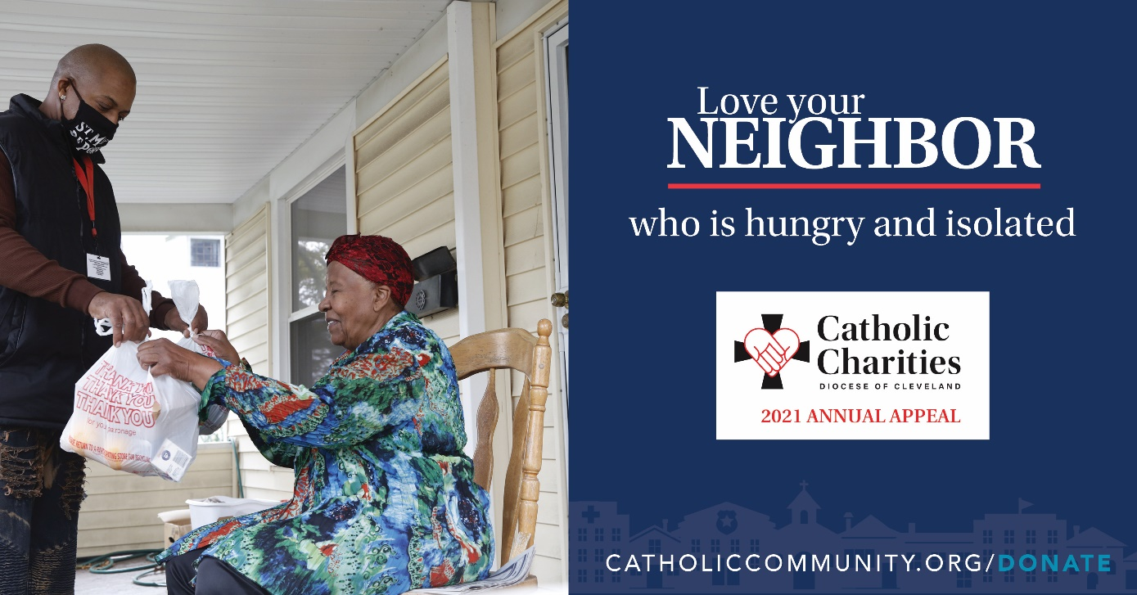
Double your impact! A generous donor, who believes in the mission of Catholic Charities, will match your gift, up to $1 million. Do twice as much good when you give online at CatholicCommunity.org/Match. Thank you!
Additional materials can be found at CatholicCommunity.org/ParishMaterials
or by contacting Sarah Yantek: 216-696-6525 x1049, syantek@catholiccommuniy.org

