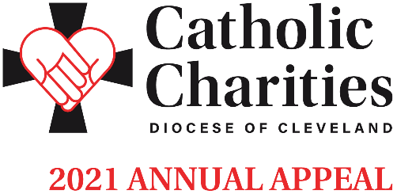

ANNOUNCEMENT WEEKEND | FEBRUARY 13-14

Bulletin and Pulpit Announcements

The 2021 Catholic Charities Annual Appeal will take place next weekend in our parish. Please refer to the insert in this week’s bulletin which includes our parish’s goal and an overview of the importance of Catholic Charities in our communities. This year’s appeal theme is Love Your Neighbor. Your generous support will transform the lives of others, to offer dignity, possibilities and companionship to those who are most vulnerable.
As in the past, an in-pew commitment process will take place next weekend, February 20-21. All who have not received the mailing from Bishop Malesic, or have not had a chance to respond to it, will be asked to consider making a generous pledge to support the ministries and services provided by Catholic Charities. If you have received the mailing, please respond generously to it and we ask you to also complete the in-pew envelope and indicate by checking the box that you have responded by mail.
SCAN ME!

We invite you to view stories of inspiration and more information at CatholicCommunity.org/2021Appeal.

Double your impact! A generous donor, who believes in the mission of Catholic Charities, will match your gift, up to $1 million. Do twice as much good when you give online at CatholicCommunity.org/Match. Thank you!
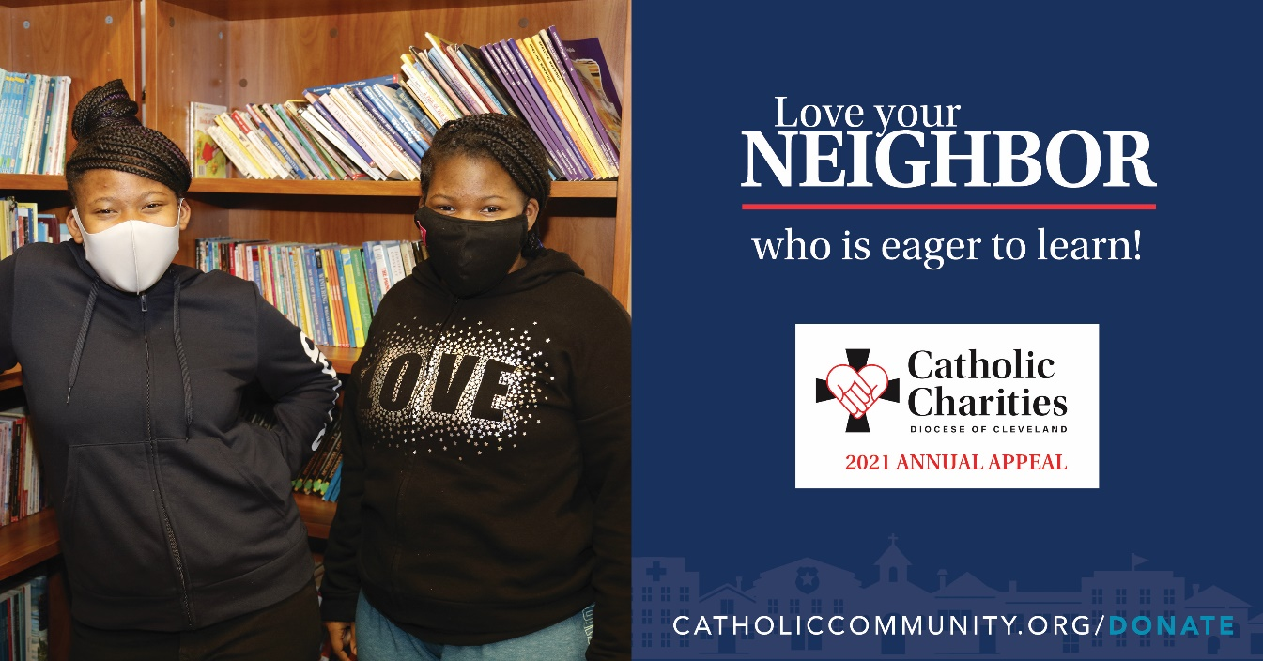
Additional materials can be found at CatholicCommunity.org/ParishMaterials
or by contacting Sarah Yantek: 216-696-6525 x1049, syantek@catholiccommuniy.org

