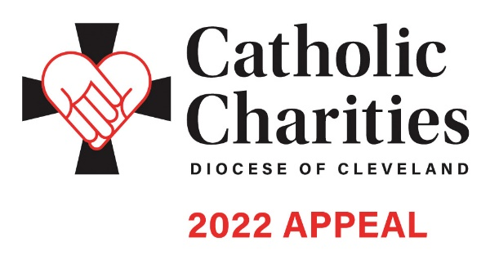In Pew Weekend | February 19-20

Bulletin and Pulpit Announcements

The 2022 Catholic Charities Appeal is underway with an in-pew commitment process taking place this weekend. This is not a special collection; rather, the Catholic Charities Appeal represents the chance for all Catholics to make a significant pledge, payable in installments, to Catholic Charities, Diocese of Cleveland in order to support its mission of a society that stands united in its support of the “least among us.”

Many parishioners have received a letter from Bishop Malesic requesting their support. If you have not received this letter, please respond to the in-pew commitment process today! If you have received the mailing, please respond to it. There is a box on the in-pew envelope to indicate that you have responded by mail.

Be the Light. Your support of the 2022 Catholic Charities Appeal helps us to carry out the mission that Jesus entrusted to us: I say to you, whatever you did for one of these least brothers of mine, you did for me.’ Please consider a generous gift that will change the lives of the 400,000 who are served each year in Northeast Ohio. Please pray for the success of the Appeal, which provides for essential programs and services in need throughout all eight counties of the Diocese of Cleveland.
Additional materials can be found at CatholicCommunity.org/ParishMaterials
or by contacting Sarah Gozur: 216-696-6525 x1910, sgozur@catholiccommuniy.org

