The following bulletin is recommended for reporting your parish’s progress towards goal.

Use the parish stats, add your numbers to the yellow highlighted areas below and share with your parishioners the progress that is beingmade atyour parish and thank them for their participation.

Bulletin Announcement – October Results

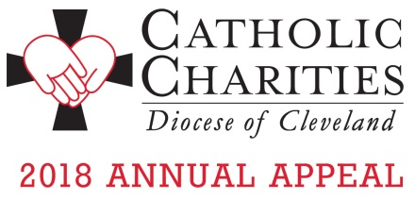
You Did It! The 2018 Appeal is OVER GOAL and Growing!
It is truly heartwarming to see more people getting the services they need to survive because you took the time to support the Appeal. As the Appeal dollars grow, so do the numbers of people in need. We can't stop now; there are people like John who needs your help to continue to remain sober, employed and in his own apartment.
Your continuing support of the 2018 Catholic Charities Annual Appeal is making a difference. As of October 31st, a total of 46,985 donors have pledged $13,074,803 to the Appeal. Each of you who have made a gift is the reason for this success.

Here at <insert parish name>, <Insert number of donors> parishioners have pledged $<insert dollars pledged> toward our parish goal of $<insert parish goal>. That is <insert % to goal> of our overall goal! Your support makes a difference and transforms lives. Watch stories of transformation and see the faces of those impacted by your generosity. Please visit: www.catholiccommunity.org/2018appeal

Your gifts are still important if we are to meet the expanding needs of the most vulnerable. There is still time to donate before year end. Contact Karen Joyce at 216-696-6525 ext. 1910 or make a secure online gift at www.catholiccommunity.org/donate.

