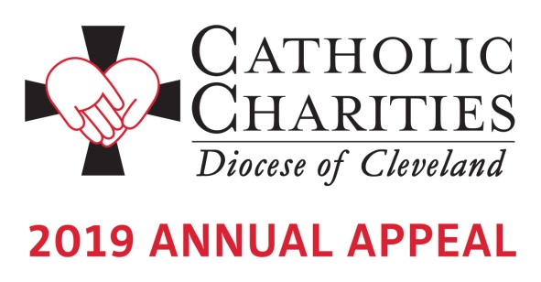

Bulletin and Pulpit Announcements:
ANNOUNCEMENT WEEKEND - FEBRUARY 2-3

The 2019 Catholic Charities Annual Appeal will take place next weekend in our parish. Please refer to the insert in this week’s bulletin which includes our parish’s goal and an overview of the importance of Catholic Charities in our communities. This year’s appeal theme is Walk in Faith. Give in Joy. Your generous support will transform the lives of others, to offer dignity, possibilities and companionship to those who are most vulnerable. Hear from three people whose lives have been transformed by you at www.catholiccommunity.org/videos.

As in the past, an in-pew commitment process will take place next weekend, February 9-10. All who have not received the mailing from Bishop Perez, or have not had a chance to respond to it, will be asked to consider making a generous pledge to support the ministries and services provided by Catholic Charities. If you have received the mailing, please respond generously.
For more information about the Appeal and how your gifts will be used to help others, visit www.catholiccommunity.org/2019Appeal or contact Karen Joyce at 216-696-6525 X 1910 or kjoyce@catholiccommunity.org.

Prayers of the Faithful:
That the love of God might be seen in the love that we show to the least of our brothers and sisters through our support of the Catholic Charities Annual Appeal. We pray to the Lord…

