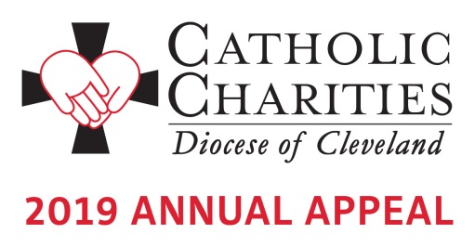

Bulletin and Pulpit Announcements:
IN-PEW APPEAL WEEKEND - FEBRUARY 9-10

The 2019 Catholic Charities Annual Appeal is underway with an in-pew commitment process taking place this weekend. This is not a special collection; rather, the Catholic Charities Annual Appeal represents the chance for all Catholics to make a significant pledge, payable in installments, to Catholic Charities, Diocese of Cleveland in order to support its mission of a society that stands united in its support of the “least among us.” Many parishioners have received a letter from Bishop Perez requesting their support. If you have not received this letter, please respond to the in-pew commitment process today! If you have received the mailing, please respond to it. There is a box on the in-pew envelope to indicate that you have responded by mail. To give online visit www.catholiccommunity.org/donate or call Karen Joyce at 216-696-6525 X 1910 or kjoyce@catholiccommunity.org.

Walk in Faith. Give in Joy. Your support of the 2019 Catholic Charities Annual Appeal helps us to all become missionary disciples. Please consider a generous gift that will change the lives of people like David, Marian, Shaye and Sharita. Hear their stories of transformation at www.catholiccommunity.org/videos. On behalf of the poor and needy of Northeast Ohio, thank you for your commitment to make a difference in the lives of those less fortunate.

Prayers of the Faithful:
That the church might continue to grow in holiness through merciful mission to those who are most in need of God’s love;
That our Pope Francis, our Bishop Nelson Perez, and all bishops will recognize God’s call to mission on behalf of all people neglected by society;
That the success of our 2019 “Walk in Faith. Give in Joy.” Catholic Charities Appeal might shower with mercy those who are hurting: our homeless, our hungry, our unemployed, and our addicted;
That our elderly, our chronically ill and those living with disabilities might find in our parish community respect, dignity and Christian love;
That the love of God might be seen in the love that we show to the least of our brothers and sisters;
That we might embrace our poor and our suffering sisters and brothers as Christ embraces and loves the outcast of society;
That God’s voice calling us and empowering us for mission in his name might stir our hearts to mercy, compassion, and love for all humanity;
That we might seek more and more the merciful and empowering love of God through the sacrament of Penance

