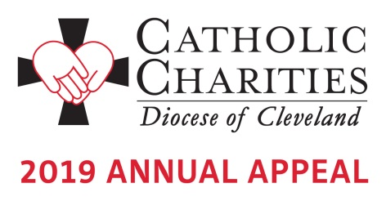

Bulletin and Pulpit Announcements: January 19-27

Walk in Faith. Give in Joy. Your support of the 2019 Catholic Charities Annual Appeal will help us serve those individuals who are most in need and most vulnerable. What does it mean to Walk in Faith and Give in Joy? It means that we are to continue the work of Christ on earth; to show mercy to our brothers and sisters in need no matter their background or circumstances. When we do this with joy, we act as missionary disciples.

Please give generously to this year’s Appeal. Your gifts will change lives as they did for David, Marian, Shaye and Sharita who are featured in our new video. Hear their stories of transformation at www.CatholicCommunitiy.org/videos.

Many parishioners received letters from Bishop Perez in mid-January inviting their support of the 2019 Annual Appeal. Please pray for the good work of Catholic Charities and give today. Your donation makes a difference! To learn more about the Appeal or to give online, visit www.CatholicCommunity.org/2019Appeal or contact Karen Joyce at 216-696-6525 X 1910; kjoyce@catholiccommunity.org

Prayers of the Faithful:
That, through the faces of those with disabilities, those with addiction, and those who strive for a brighter future, we may see the face of Christ and respond to the Catholic Charities Annual Appeal in a way that speaks to their dignity. We pray to the Lord…

