The following bulletin is recommended for reporting your parish’s progress towards goal.

Use the parish stats, add your numbers to the yellow highlighted areas below and share with your parishioners the progress that is being made at your parish and thank them for their participation.

Bulletin Announcement – August Results

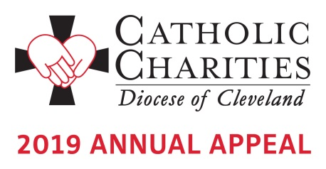
Your generosity to the 2019 Catholic Charities Annual Appeal is why lives are being changed everyday across our diocese. Because of you, Marian has found happiness again after several health issues sidelined her and she could no longer work. “I was so depressed”, shared Marian. “I had always been active.” Her depression did not last long after she was introduced to Catholic Charities and Summit Adult Day Services. “I come here three days a week. I do yoga. I love my creative arts class,” says an enthusiastic Marian. “People say I haven’t been this happy in years.” For more about Marian and to read other inspirational stories of hope and healing as a result of your gifts, visit www.CatholicCommunity.org/2019Appeal. As of August 31st, a total of 44,499 faithful donors from across the Diocese have pledged $12.5 million towards the Annual Appeal goal of $13.5 million.

Here at <insert parish name>, <Insert number of donors> parishioners have pledged $<insert dollars pledged> toward our parish goal of $<insert parish goal>. That is <insert % to goal> of our overall goal! Your financial support makes a difference and transforms lives. Thank you on behalf of those served by Catholic Charities.
If you have not yet made your gift, contact Karen Joyce at 216-696-6525 x1910 to give by phone or make a secure online gift at www.CatholicCommunity.org/donate.

