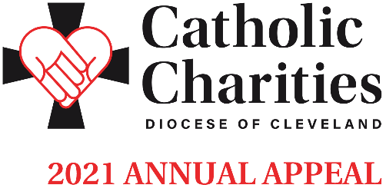

Email Template In-Pew Weekend | Week of February 14
Dear <Salutation>,

This weekend at <Parish Name>, we will be promoting the Catholic Charities Annual Appeal through an In-Pew campaign, as well as the option to make a donation online or through the mail. The theme of the 2021 Appeal is Love Your Neighbor. As One Body in Christ, let us take this opportunity to help our neighbors in need by supporting the essential programs and services that provide assistance to over 400,000 individuals in need across Northeast Ohio.

ANNOUNCEMENT: $1 MILLION DOLLAR MATCH
I am excited to share that all donations made to Catholic Charities will be matched dollar for dollar this weekend, thanks to a million dollar grant from an anonymous donor.
WAYS TO GIVE
• In the pews this weekend
• Text CCHOPE to 41444
• CatholicCommunity.org/MATCH
SCAN ME!

Watch: Bishop Malesic Introduces Catholic Charities 2021 Annual Appeal

Thank you for your generosity and support of this essential Annual Appeal in our community. May God continue to bless you and your loved ones.

<Pastor Name>

Additional materials can be found at CatholicCommunity.org/ParishMaterials
or by contacting Sarah Yantek: 216-696-6525 x1049, syantek@catholiccommunity.org

