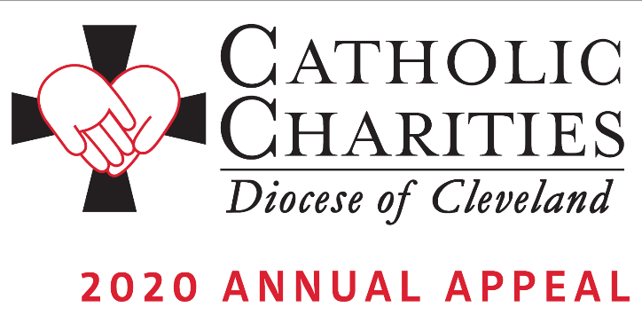

Announcement Weekend – February 1-2

Bulletin and Pulpit Announcements:
The 2020 Catholic Charities Annual Appeal will take place next weekend in our parish. Please refer to the insert in this week’s bulletin which includes our parish’s goal and an overview of the importance of Catholic Charities in our communities. This year’s appeal theme is Faces of Hope. Your generous support will transform the lives of others, to offer dignity, possibilities and companionship to those who are most vulnerable.

As in the past, an in-pew commitment process will take place next weekend, February 8-9. All who have not received the mailing from Bishop Perez, or have not had a chance to respond to it, will be asked to consider making a generous pledge to support the ministries and services provided by Catholic Charities. If you have received the mailing, please respond generously to it and we ask you to also complete the in-pew envelope and indicate by checking the box that you have responded by mail.

We invite you to view stories of inspiration and more information at CatholicCommunity.org/2020Appeal.

To make a donation today, text CCHOPE to 41444 or visit CatholicCommunity.org/Donate.

Prayers of the Faithful:
That the love of God might be seen in the love that we show to the least of our brothers and sisters through our support of the Catholic Charities Annual Appeal. We pray to the Lord…

