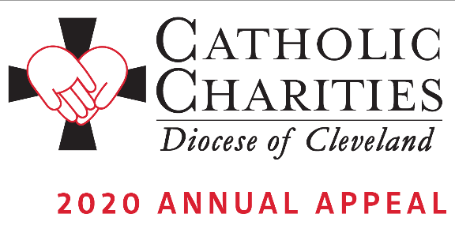

COMMITMENT WEEKEND – FEBRUARY 8-9

Bulletin and Pulpit Announcements:
The 2020 Catholic Charities Annual Appeal is underway with an in-pew commitment process taking place this weekend. This is not a special collection; rather, the Catholic Charities Annual Appeal represents the chance for all Catholics to make a significant pledge, payable in installments, to Catholic Charities, Diocese of Cleveland in order to support its mission of a society that stands united in its support of the “least among us.” Many parishioners have received a letter from Bishop Perez requesting their support. If you have not received this letter, please respond to the in-pew commitment process today! If you have received the mailing, please respond to it. There is a box on the in-pew envelope to indicate that you have responded by mail.

Faces of Hope. Your support of the 2020 Catholic Charities Annual Appeal helps us to carry out the mission that Jesus entrusted to us: I say to you, whatever you did for one of these least brothers of mine, you did for me.’ Please consider a generous gift that will change the lives of the 410,000 who are served each year in Northeast Ohio. Please pray for the success of the Appeal, which provides for essential programs and services in need throughout all eight counties of the Diocese of Cleveland.
On behalf of the poor and needy of Northeast Ohio, thank you! We invite you to view stories of inspiration and more information at CatholicCommunity.org/2020Appeal.
To make a donation today, text CCHOPE to 41444 or visit CatholicCommunity.org/Donate.

Prayers of the Faithful
That the church might continue to grow in holiness through merciful mission to those who are most in need of God’s love;
That our Pope Francis, our Bishop Nelson Perez, and all bishops will recognize God’s call to mission on behalf of all people neglected by society;
That the success of our 2020 “Faces of Hope” Catholic Charities Appeal might shower with mercy those who are hurting: our homeless, our hungry, our unemployed, and our addicted;
That our elderly, our chronically ill and those living with disabilities might find in our parish community respect, dignity and Christian love;
That the love of God might be seen in the love that we show to the least of our brothers and sisters;
That we might embrace our poor and our suffering sisters and brothers as Christ embraces and loves the outcast of society;
That God’s voice calling us and empowering us for mission in his name might stir our hearts to mercy, compassion, and love for all humanity;
That we might seek more and more the merciful and empowering love of God through the sacrament of Penance

