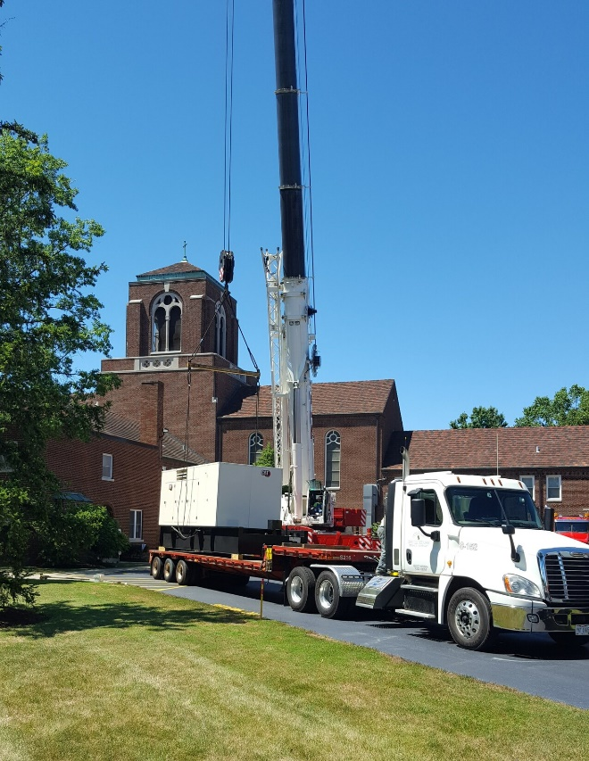
Major electrical project is nearly complete at Center for Pastoral Leadership
The coronavirus pandemic is causing disruptions for many, but it proved to be a blessing for work scheduled at the Catholic Diocese of Cleveland’s Center for Pastoral Leadership in Wickliffe.
Phil Guban, treasurer of Borromeo and Saint Mary seminaries and CPL chief operating officer, said a major electrical upgrade was scheduled for the 45-acre campus in conjunction with other planned renovations to the main building. Classes switched to remote learning in March, so not many people have been on the CPL campus, which consists of seven buildings. In addition to the two seminaries, its main tenants include All Saints School of St. John Vianney, the permanent diaconate offices, pastoral ministry office, office of continuing education and formation of ministers and the COAR Peace Mission.
“With so few people there, we decided it would be a good time to proceed with the CPL campus electrical upgrade,” Guban said.
The project, which cost about $1.6 million, is funded in part by early donors to the Heart of a Shepherd initiative, which will be introduced to all parishes across the diocese in 2021. The improvements included:
- Underground wiring conduits and concrete vaults
- New transformers for CPL main building and All Saints School building
- New main distribution panel in CPL main building and All Saints School building
- New secondary feeder lines from all transformers to main distribution panels
- Installation of two generators:
  - Generator #1 covers main building, St. Anthony Center, and the field house.
  - Generator #2 covers All Saints School, Issenmann building and the auditorium.
  - The Issenmann building transformer was replaced in 2017.
  - New automatic transfer switches at main building, Issenmann building and All Saints School building. The automatic transfer switches, engage generators when there is a power failure.
Bryan Stadnik, diocesan representative for the CPL project, said there was not enough power being supplied to the campus for additional planned renovation work. He said the electrical work took place behind the scenes and is important to ensuring that there is enough power supplied when work begins on the second floor of the main building.
“I’m cautiously optimistic the next phase will start sometime next spring, after the conclusion of the school year,” Guban said.
Stadnik said FirstEnergy owns the transformers and the diocese owns the feeder lines (underground) and generators. The original feeder lines were installed in 1947.
“We had to completely shut down power to the entire campus, install the new components and then connect everything,” Guban said.
Crews worked two shifts of 10-12 hours daily, seven days a week for two weeks to complete the job, Stadnik said. The first shift included 14 people and there were four to six on the second shift.
“It was a tremendous amount of work,” he said.
One more part is on order and should be installed by October, Stadnik added.
Guban said all electrical components from the street to the internal distribution panel were replaced.
“A lot of thought went into this project,” he said, noting discussions began nearly 15 years ago to update and renovate the CPL. It involves updating an antiquated building that originally housed Marycrest School for Girls. In 1953, the diocese took over the site for Borromeo Seminary, the diocesan minor seminary that included a high school and college program. The high school was phased out in 1976.
After much study and conversation, Saint Mary Seminary moved from its Ansel Road location to the site in 1991 and the CPL was established. Guban said additions were built in 1957 and 1961. In 1991, the first floor was remodeled and air conditioning was added in some spaces and offices.
The next phase of the project will remodel living spaces for the seminarians. Rooms will be reconfigured as private rooms with bathrooms. Currently, students use common bathrooms. Guban said there will be about 120 rooms available for seminarians when the project is finished.
The Heart of a Shepherd initiative is a fundraising effort designed to strengthen and better meet the needs of Saint Mary and Borromeo seminaries, the seminarians and newly ordained and retired clergy in the diocese. To learn more about Heart of a Shepherd, contact Patrick Grace, executive director of the Catholic Community Foundation, 216-696-6525, Ext. 5750.

