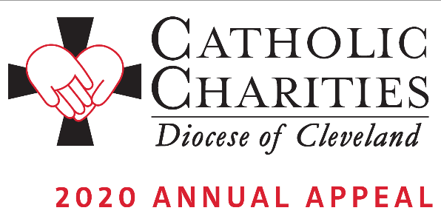

Bulletin and Pulpit Announcements: January 18-26

Faces of Hope. Though we are many, we are one in Christ. Many parishioners received letters in January, inviting their support of the Annual Appeal. Please pray for the good work of Catholic Charities and make a pledge today. Your donation makes a difference!
Your support of the 2020 Catholic Charities Annual Appeal will help us serve those individuals who are most in need and most vulnerable. From Matthew’s Gospel: Whatever you did for the least of these, you did it for me. When we feed the hungry, take care of the sick, and welcome the stranger, we are also serving Jesus himself.
We appreciate your donation and will take special care to use it wisely in providing essential programs and services to people in need throughout all eight counties of the Diocese of Cleveland.
We invite you to view stories of inspiration and more information at CatholicCommunity.org/2020Appeal.
To make a donation today, text CCHOPE to 41444 or visit CatholicCommunity.org/Donate.
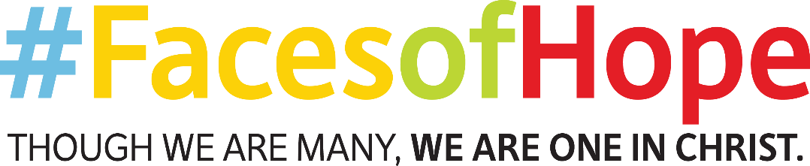

Prayers of the Faithful:
That, through the faces of those with disabilities, those with addiction, and those who strive for a brighter future, we may see the face of Christ and respond to the Catholic Charities Annual Appeal in a way that speaks to their dignity. We pray to the Lord…

