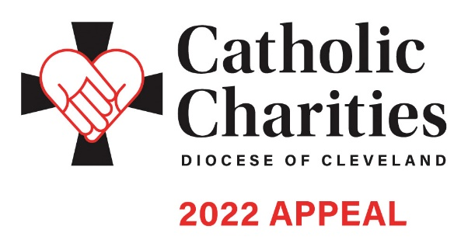In Pew Weekend | February 19-20

EMAIL COMMUNICATION

Template for Week of February 13

Dear <Salutation>,

At <Parish Name>, we are blessed to be given many opportunities to support those in need in our communities, remembering as Christians that we are called to be the light of the world through our faith and generosity.

You are the light of the world. A city set on a mountain cannot be hidden. Nor do they light a lamp and then put in under a bushel basket; it is set on a lampstand, where it gives light to all in the house. Just so, your light must shine before others, that they may see your good deeds and glorify your heavenly Father. (Matthew 14:16)

This weekend at <Parish Name>, we will be promoting the Catholic Charities Appeal through an In-Pew campaign, as well as the option to make a donation online, via text, or through the mail. The theme of the 2022 Appeal is Be the Light. Let us take this opportunity to help our neighbors in need by supporting the essential programs and services that provide assistance to nearly 400,000 individuals in need across Northeast Ohio.

<Video of Bishop Malesic>

If you will not be at Mass this weekend, you can make a gift to the Appeal at any time by visiting CatholicCommunity. org/donate or texting CCHOPE to 41444, or by mailing your check to the Catholic Community Foundation at 1404 E. 9th St., 8th Floor, Cleveland, OH 44114.

To view additional impact stories and learn more about Catholic Charities, please visit CatholicCommuniy. org/2022Appeal. Thank you for your generosity and support of this essential Appeal in our community.

May God continue to bless you and your loved ones,

<Pastor Name>

Additional materials can be found at CatholicCommunity.org/ParishMaterials
or by contacting Sarah Gozur: 216-696-6525 x1910, sgozur@catholiccommuniy.org

