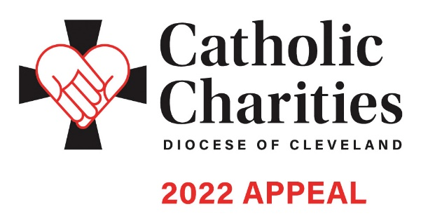In Pew Weekend | February 19-20

EMAIL COMMUNICATION

Template for After In Pew: Week of February 21

Dear <Salutation>,
Thank you to all who participated in Catholic Charities In-Pew weekend at <Parish Name>! Because of your support, nearly 400,000 individuals will receive help and hope through the programs and services made possible by people like you.

<Add thank you video>

If you have not had a chance to make a gift, please visit CatholicCommunity.org/donate, mail your donation to the Catholic Community Foundation at 1404 E. 9th St, Cleveland OH 44114, or text CCHOPE to 41444.

May God continue to bless you and your loved ones,

<Pastor Name>

Additional materials can be found at CatholicCommunity.org/ParishMaterials
or by contacting Sarah Gozur: 216-696-6525 x1910, sgozur@catholiccommuniy.org

