Paragraph to introduce Explainer Video:
New Ohio Scholarship Tax-Credit Program Lets “Turn taxes into Tuition” by directing Your Tax Dollars to our Catholic School Students

Through the Angel Scholarship Fund, you can now contribute funds that will be used to provide tuition assistance for students to attend our Catholic schools, for which you may receive a 100% Ohio income tax credit of up to $750 ($1,500 if married filing jointly) against your 2022 state tax liability. In other words, the state of Ohio allows you to "spend" some of the state income taxes you must pay anyway to provide tuition assistance for students seeking an education in our Catholic schools. The Angel Scholarship Fund is a win-win-win for taxpayer donors, scholarship recipients, and our Catholic schools. This short video explains how easy it is to contribute to the Angel Scholarship Fund:

Link the above graphic to: https://www.catholiccommunity.org/angel-scholarship-fund/videos#video-687761970

Paragraph to introduce Bishop Malesic video:
The New Angel Scholarship Fund Strengthens Our Schools And Our Future – Turning taxes into Tuition

In this short video, Bishop Edward Malesic invites you to turn your tax dollars into tuition through a new Ohio Scholarship Tax Credit Program that allows you to direct your tax dollars to the private school of your choice. Donations to the Angel Scholarship Fund are eligible for a 100% tax credit of up to $750 ($1,500 if married filing jointly) against your 2022 state tax liability. In other words, the state of Ohio allows you to "spend" some of the state income taxes you must pay anyway to provide tuition assistance for students seeking an education in our Catholic schools. Please watch this brief video:
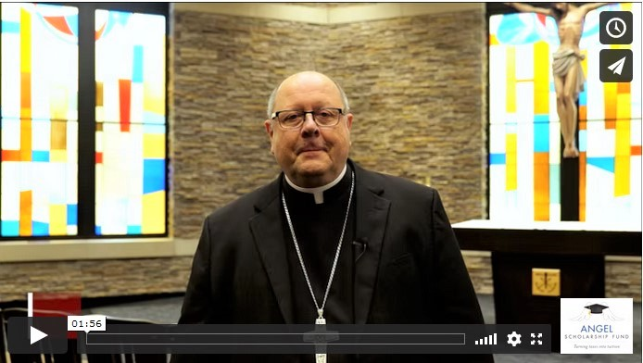
Link the above graphic to: https://www.catholiccommunity.org/angel-scholarship-fund/videos#video-695818102

