The following bulletin is recommended for reporting your parish’s progress towards goal.

Use the parish stats, add your numbers to the yellow highlighted areas below and share with your parishioners the progress that is being made at your parish and thank them for their participation.

Bulletin Announcement – September Results
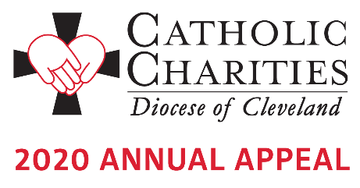
Thank you! Your support of the Annual Appeal has made a difference, especially as the needs of our communities continue to grow during COVID-19. Because of your generosity, people who are hungry and homeless, addicted and struggling, lonely, sick and hurting will have the services available to assist them during the pandemic and have hope for the future. You can find stories of hope and faith when you visit www.CatholicCommunity.org/COVIDVideo. As of September 30th, a total of 39,425 faithful donors from across the Diocese have pledged more than $12.6 million towards the Annual Appeal goal of $13.5 million.

Here at <insert parish name>, <Insert number of donors> parishioners have pledged $<insert dollars pledged> toward our parish goal of $<insert parish goal>. That is <insert % to goal> of our overall goal! Your financial support makes a difference and transforms lives. Thank you on behalf of those served by Catholic Charities.

If you have not yet made your gift, contact Karen Joyce at 216-696-6525 x1910 to give by phone or make a secure online gift at www.CatholicCommunity.org/donate.

